|  |  |
| --- | --- |
| **Project Name** | CHEP - Gateway Provisioning |
| **Project Sponsor** | CHEP |
| **Project Manager** | Sujayeendra Vallur |
| **QA Analyst** | Srujan Reddy M |
| **Project BA** | Ganesh/Sarthak |
| **Target Go Live Date** | 05/31/2019 (First Go-Live)  06/14/2019 (Second Go-Live) |

**Document Information and Approvals**

|  |
| --- |
| **Version History** |

|  |  |  |  |
| --- | --- | --- | --- |
| **Version** | **Date** | **Revised By** | **Reason for change** |
| **Version 1** | **03-18-2019** | **Srujan Reddy M** | **Initial Document** |
|  |  |  |  |
|  |  |  |  |
|  |  |  |  |

|  |
| --- |
| **Document Approvals** |

|  |  |  |  |
| --- | --- | --- | --- |
| **Approver Name** | **Project Role** | **Signature/Electronic Approval** | **Date** |
| **Sujayeendra Vallur** | **Project Manager** | **No** | **MON-DD-YY** |
| **Ganesh/Sarthak** | **Business Analyst** | **No** | **MON-DD-YY** |
| **Srinivas Shada** | **System Analyst** | **No** | **MON-DD-YY** |
| **Srinivas Shada** | **BRM** | **No** | **MON-DD-YY** |
|  | **Business Lead** | **No** | **MON-DD-YY** |

***Note: Electronic Approvals (emails) can be found as attachments in HP ALM for this project with the QA Test Plan document.***

Table of Contents

Introduction 5

QA Project Responsibilities 5

Entrance Criteria to Unit 6

Entrance Criteria to SIT 6

Entrance Criteria to FIT 6

Entrance Criteria to UAT 7

Entrance Criteria to Regression 7

Testing Environment 7

Timeline for Testing 8

Testing Execution 8

Unit Testing 10

System Integration Testing 10

Functional Integration Testing (FIT) 10

User Acceptance Testing (UAT) 10

Regression Testing 10

Exit Criteria for a Waterfall Project 11

UNIT 11

SIT 11

FIT 11

UAT 11

Regression 11

Sign Off 12

Standard Reports 12

Defect Management 12

Assumptions 14

Risks *(these are examples please update)* 14

Test Summary 15

Introduction

New user creation for all SAP FIORI applications is handled through SNOW and Curion at present.

Current process does not allow for the following:

* A new user to request access for multiple plants at the same time
* An existing user to request access for an additional plant(s)
* An existing user to request access for an additional role(s)
* A non-plant user to request access to non-plant roles

Curion is causing several production issues and it is also cumbersome to support. The purpose of this request is to enhancement the existing process flow to include the above-mentioned functionalities and eliminate Curion from the process.

*.*

QA Project Responsibilities

* Quality Assurance objectives of testing “CHEP - Gateway Provisioning” are to ensure the delivery of the highest quality software changes for the project. CHEP - Gateway Provisioning, the QA Analyst for the project will:
* Write the test plan which is written after the BRD is successfully completed.
* Ensure the setup of HP ALM including the creation of the project, users added to the project, cycles (releases) added to the project, default owner for defects assigned, releases/cycles setup for the project and provide reporting of testing.
* Provide two standard reports (refer to page 7).
* upload and/or copy test cases in HP ALM when required.
* Write test cases for the purpose of QA FIT testing. QA analyst will run some prioritized business scenarios approved by BA's during the QA FIT cycles to ensure system is functioning as required prior to UAT cycle, creating defects as needed.
* monitor test runs and work with testers as needed to ensure ‘Failed’ and ‘Not Completed’ test runs are resolved. This will ensure HP ALM is clean for the audit process.
* ensure that the HP ALM audit compliance is being adhered to throughout the project.
* provide sign-off once the testing has been completed and HP ALM is in the finalized state for moving to production.
* ensure with project team that test data is set up and ready in the test environment at least 2 days prior to start of UAT Testing.
* ensure that security testing is carried out in FIT and UAT test cycles.
* ensure a change control must be created for any project changes moving to the production environment.

Entrance Criteria to Unit

* Functional Specifications (BRD) signed off.
* Complete or partially complete code is available.
* All hardware/applications needed for the test environment is available and data has been refreshed (when possible).
* All user setup configurations are complete in the application being tested.
* Testers have access to HP ALM or JIRA.
* Test cases uploaded.
* Test cases will not be deleted once Unit testing has commenced.

Entrance Criteria to SIT

* All Unit test scripts are completed.
* No Urgent defects opened or defects that will affect System Integration testing.
* If unable to close defects, isolate the affected areas for SIT.
* SIT testing may only commence when these defects are closed.
* All hardware/applications needed for the test environment is available and data has been refreshed (when possible).
* All software configurations are complete in the application(s) being tested.
* All user setup configurations are complete in the application being tested.
* Testers have access to HP ALM.
* Test cases uploaded.
* Test cases will not be deleted once SIT testing has commenced.

Entrance Criteria to FIT

* All Unit test scripts are completed.
* No Urgent defects opened or defects that will affect Functional Integration testing.
* If unable to close defects, isolate the affected areas for FIT.
* FIT testing may only commence when these defects are closed.
* All hardware/applications needed for the test environment is available and data has been refreshed (when possible).
* All software configurations are complete in the application(s) being tested.
* All user setup configurations are complete in the application being tested.
* Testers have access to HP ALM.
* Test cases uploaded.
* Test cases will not be deleted once FIT testing has commenced.

Entrance Criteria to UAT

* All UNIT/FIT/SIT test scripts are completed.
* No Urgent defects opened or defects that will affect UAT testing.
* If unable to close defects, isolate the affected areas for UAT testing.
* UAT testing may only commence when these defects are closed.
* All hardware/applications needed for the test environment is available and data has been refreshed (when possible)
* All software configurations are complete in the application(s) being tested
* All user setup configurations are complete in the application being tested
* Testers have access to HP ALM
* Test cases uploaded
* Test cases will not be deleted once UAT testing has commenced

Entrance Criteria to Regression

* All UAT test scripts are completed
* No Urgent defects opened or defects that will affect Regression testing.
* If unable to close defects, isolate the affected areas for Regression testing.
* Regression testing may only commence when these defects are closed.

Testing Environment

All testing activities are required to be documented in HP ALM <http://qualitycenter.chep.com/qcbin/>

* **Domain:** *[Enter Domain Name]*
* **Project: CHEP - Gateway Provisioning**

Timeline for Testing

Key dates for start and end of each phase of testing, maybe generic initially, and refined by month 1 and locked down by Gate 3 review.

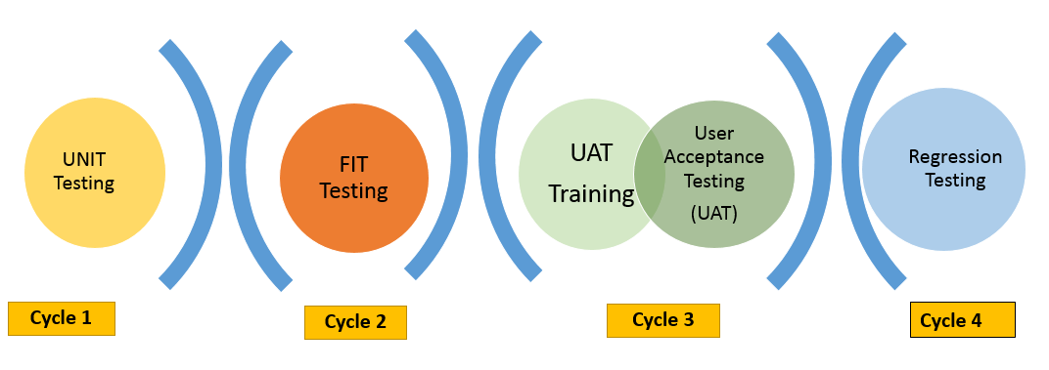

Testing Execution

***{This section will identify applicable test cycles, individual(s) responsible for creating and executing test scripts, and the location of test cases (DOMAIN AND PROJECT NAME) in HP ALM}***

* SA will own System Integration testing, ensuring proper integration testing is completed between systems to be logged in HP ALM.
* Developers are responsible for unit testing of the developed code. This can be logged in JIRA or HP ALM.
* BA will identify business users responsible for UAT and Regression Testing.
* BA responsible for ensuring roles and security test scenarios are created.
* BA is responsible for managing business testing (UAT and Regression Testing) including reporting.
* QA is responsible for managing IT testing (UNIT, QA FIT, SIT, IT Regression, Automation) including reporting.
* IT Testers – 1 SNOW (Service Now) ticket for all testers may be raised per project.
* Business Testers – 1 SNOW (Service Now) ticket to be raised per tester, per project by the tester.
* New Testers - Access will only be granted once the HP ALM Audit Compliance training has been completed in Cornerstone by the tester.
* PM to ensure that the Security team are included in the project.

|  |  |  |  |  |  |  |
| --- | --- | --- | --- | --- | --- | --- |
| Phase | Created By | Due Date | Testing Lead | Executed By | Start Date | End Date |
| Unit Testing | Bhanu Teja,  Navaz Sheik |  | Srininvas Shada,  Santosh Marapalli | Bhanu Teja,  Navaz Sheik | 04/05/2019 | 05/06/2019 |
| System Integration Testing (SIT) | Srujan M |  |  | Srujan M | 05/07/2019 | 05/17/2019 |
| Functional Integration Testing (FIT) | Srujan M |  |  | Srujan M | 05/14/2019 | 05/17/2019 |
| FIT – Security Testing | Security team | NA | NA | NA | NA | NA |
| User Acceptance Testing (UAT)  (Security testing included as a separate folder within UAT) |  |  |  | Van Staden, Marius, Blue, Chris | 05/21/2019 |  |
| Regression Testing |  |  |  |  | 05/27/2019 | 05/31/2019 |
| Mobile Testing | NA | NA | NA | NA | NA | NA |
| End-to-End Testing (E2E) |  |  |  |  | 05/21/2019 | 05/31/2019 |
| Automation Testing | NA | NA | NA | NA | NA | NA |

Unit Testing

is to be performed by the developers in their development environment. The developers will be testing the internal logical structure of each software component. Documented testing should include the following: tests performed, the expected results and the outcome of each test. 3rd Party developers are to perform Unit Testing in their own environments and provide an Excel Spreadsheet as documentation of the testing.

System Integration Testing

is to be performed by the System Analysts (SA). The SA’s will be testing to ensure that interfaces to external systems are properly working. System Integration Testing will begin on acceptance of Unit testing.

Functional Integration Testing (FIT)

focuses on the functional requirements of the application and is performed to confirm that the application operates accurately according to the documented specifications and requirements. Functional Integration Testing will begin upon acceptance of Unit Testing and SIT.

User Acceptance Testing (UAT)

will be performed by the business users. The purpose of this testing cycle will be to ensure the application meets the users’ expectations. This also includes focuses on usability and will include; appearance, consistency of controls, consistency of field naming, accuracy of drop down field information lists, spelling of all field name/data values, accuracy of default field values, tab sequence, and error/help messaging. User Acceptance Testing will begin upon completion of Functional Integration Testing. QA team will work with and train business users how to execute test cases in HP ALM prior to the start of UAT testing.

Regression Testing

Regression testing shall be performed to verify that previously tested features and functions do not have any new defects introduced, while correcting other problems or adding and modifying other features.

Exit Criteria for a Waterfall Project

UNIT

* All test cases must be run i.e. status with ‘No Run’ and ‘Not Completed’ is not accepted.
* Project code is complete.
* Urgent defects resolved.
* Successful execution of unit tests.

SIT

* All test cases must be run i.e. status with ‘No Run’ and ‘Not Completed’ is not accepted.
* Urgent defects resolved.
* Successful execution of integration tests.

FIT

* All test cases must be run i.e. status with ‘No Run’ and ‘Not Completed’ is not accepted.
* Urgent defects resolved.
* Successful execution of functional tests.

UAT

* All test cases must be run i.e. status of ‘No Run’ and ‘Not Completed’ is not accepted.
* All test cases that have a status of N/A will require an explanation for the test not being run and requires approval from the tester’s manager or project business lead.
* A plan in place if any late resolution of defects from the UAT phase must include retesting of Regression test cases.
* Successful execution of user acceptance tests.

Regression

* All test cases must be run i.e. status of ‘No Run’ and ‘Not Completed’ is not accepted.
* All test cases that have a status of N/A will require an explanation for the test not being run and requires approval from the tester manager or project business lead.
* Successful execution of regression tests.

Sign Off

An email is required from the business confirming the following;

* We have tested and satisfied that the system is ready and fit for use in production (acknowledgement of ‘open’ defects where applicable).
* An email from the tester manager or project business lead approving the tester’s scripts marked as N/A in the testing cycles.

QA Sign off requirements

* Urgent (severity) defects must have a status of ‘Closed’ for all test cycles.
* For the remaining defects; a plan discussed and approved by the business for the resolution of defects and appropriate test cases.

Standard Reports

QA will provide reports on the following through each testing phase

* Defects: Number of defects, status, and severity.
* Scripts: Number of test scripts by the testers.

Defect Management

* During UNIT and SIT, defects will be managed by the Developer/SA.
* During QA FIT, defects will be managed by the QA team.
* During UAT and Regression testing, defects will be identified by the testers and validated by person identified as the “gatekeeper”. This person is usually the BA, BRM, or QA team member assigned to the project. After the defect is validated, the gatekeeper will then assign the defect to the SA with a status of “Open”. For code changes the SA will assign the defect to the Developer, status remains “Open”. Once the defect is corrected, the Developer will update the defect status to “Fixed” and add comments in HP ALM to document the fix and assign to the SA to test. Once tested and passed the defect will be assigned to the gatekeeper with a status of “Retest” and comments added to HP ALM. The gatekeeper will then assign the defect to the tester. If the defect is confirmed fixed, the tester will then change the status to “Closed”. If the defect is not fixed, the tester will change the status to “Reopen” and assigns the defect back to the gatekeeper. This process repeats until the defect is corrected, at which time the defect status will be changed to “Closed”.

**Defect Lifecycle**

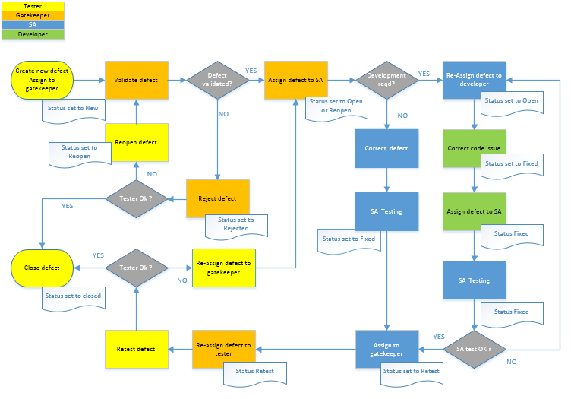

The gatekeeper will:

* reject defects that are not linked to a test case as per the audit compliance requirement.
* reject defects that do not include an attachment or screenshot as per the audit compliance requirement.
* reject defects that do not describe the process to the detailed level that is required so that SAs and Developers are able to replicate the scenario for testing purposes.
* ensure for Exploratory Testing (when a defect is picked up outside of a test suite) that a detailed test script with steps is created and linked to the defect. This allows the defect to be reproduced for root cause analysis and corrective action.
* will investigate and assign the appropriate “Root Cause” category before changing the status from “New” to “Open” and assigning to the relevant resource for resolution.
* QA team member will ensure that the project does not go live with ‘Urgent’ defects pending.

*For additional information on Defects please refer to SharePoint:* [***Defects***](https://bramblesgroup.sharepoint.com/teams/a/sqa/_layouts/15/WopiFrame.aspx?sourcedoc=%7b3DDC27AA-2B35-4A97-A3BB-8212F21AEE76%7d&file=Defects.docx&action=default)

Assumptions

*1. Other users are not considered for the Project.*

*2. Roles are Static and any new Role to be added should be a change request.*

*3. Testing is done with Test Users since BAPI are commented out as part of Add, Modify and Termination.*

*4. Bulk User update is out of scope.*

*5. Email notifications from SAP to be enabled by Andrew Johnston*

Risks *(these are examples please update)*

|  |  |
| --- | --- |
| Description | Avoidance/Mitigation |
| Timely delivery of the code. If development timelines are not met, this will directly impact the testing timelines. | Testing timeline will be pushed out |
| Time allotted for FIT and UAT testing does not account for any defects that may occur. This may require additional time for testing. | Testing timeline will have to be adjusted to account for the correction of defects |
| Aggressive target date increases the risk of defects being migrated to production. | Relax the target date or push the Testing Timeline out. |
| Scope creep (last minute addition of new requirements) impacts deadline for development team and test team | Last minute additions of new requirements will likely delay timely delivery of code. This will also delay the Testing timeline. |
| Extreme tight timeline for this project due to the controlled freeze period pertaining to the SAP Upgrade (state actual period) | Extensive FIT Testing so that defects are raised early in the testing period and ensure a smoother UAT testing. Continuous monitoring of testing timelines to ensure deadline is met. |
| Gateway User ID maintenance | Gateway User ID’s IN SAP should be mapped correctly with SAP User ID. |

Test Summary

QA will provide a test summary to the PM which will include a list of all outstanding unresolved defects and any associated risks with releasing the project to production. All outstanding issues are discussed with the PM and project team (should the PM so desire). The list of outstanding defects is also attached to the QA sign-off form.